Virtual Machine Storage

Lab Overview
In this lab, you will learn how to attach additional storage from the Azure Management Portal and manage the underlying storage using Azure Storage Explorer.

Exercise 1: Attach Additional Storage
- Within the Azure Management portal, click Browse, Virtual Machines and then click WebVM-
1.
- On the Settings Blade, under the GENERAL section, click Disks.
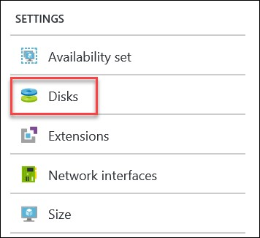
- Click Attach new.

- Specify the following settings
  - Name: WebVM-1-DataDisk1
  - Type: HDD
  - Host caching: Read/Write.
  - Location: Choose the storage account in the opsvmrmrg Resource Group and choose the vhds container (Click Select and then OK)
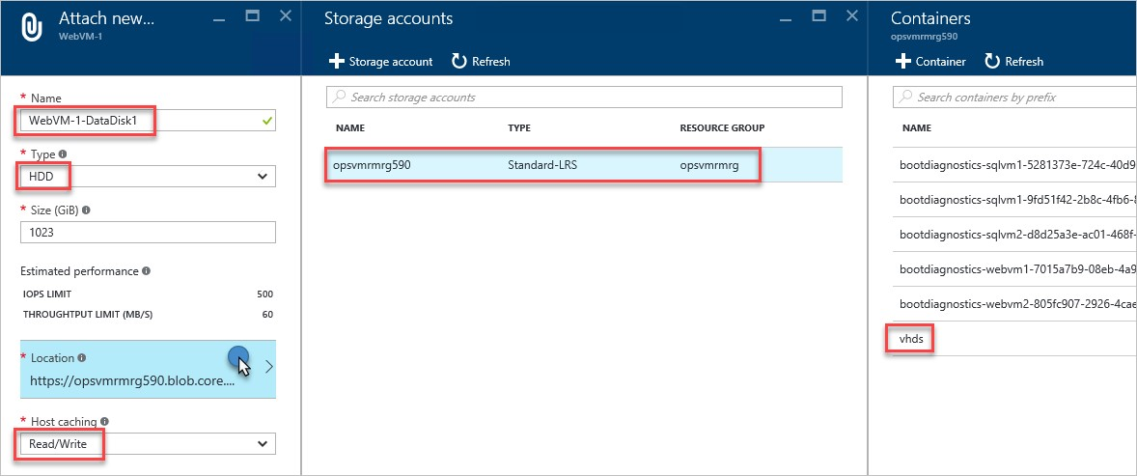

- Repeat the process and name the second disk WebVM-1-DataDisk2.
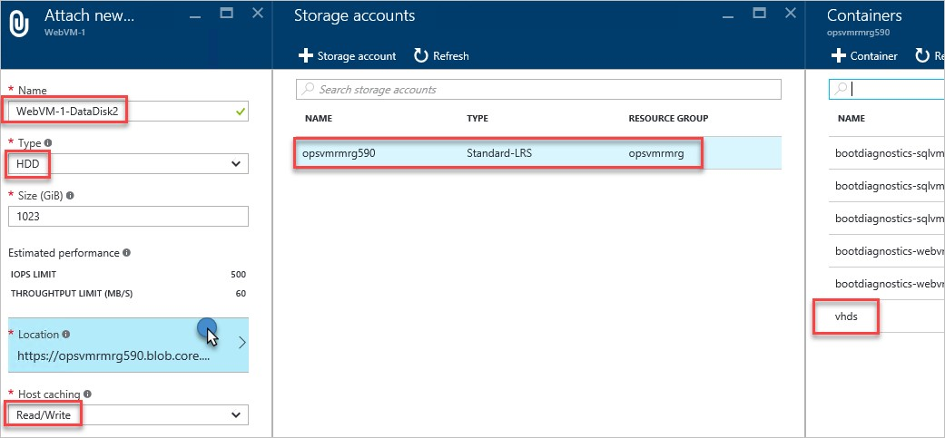

- Your disk configuration should look similar to the following:
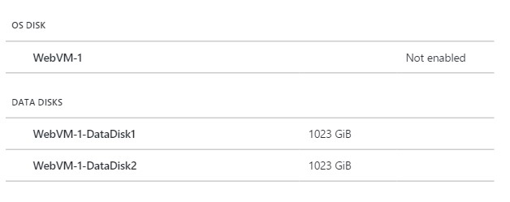

Exercise 2: Create a new Storage Space for the disks
- Click the Connect button on the toolbar for the WebVM-1 virtual to connect to it. When prompted use the following credentials:
  - Login: demouser
  - Password: demo@pass123

- Inside the virtual machine click Windows Server Manager.

- Click File and Storage Services from within Windows Server Manager.
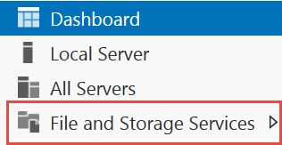

- Click Storage Pools.
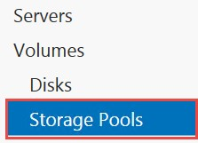

- Right click on the Primordial disks column, and click New Storage Pool.
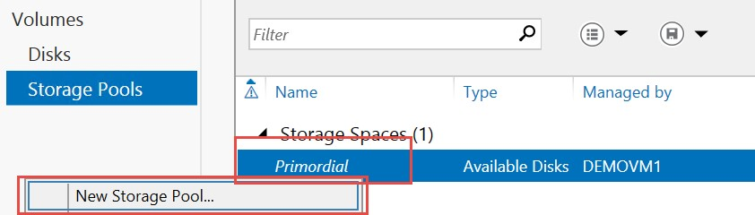

6.

Click
Next

on the before you begin step.

- Specify the name StorageSpaceDemo and click Next.
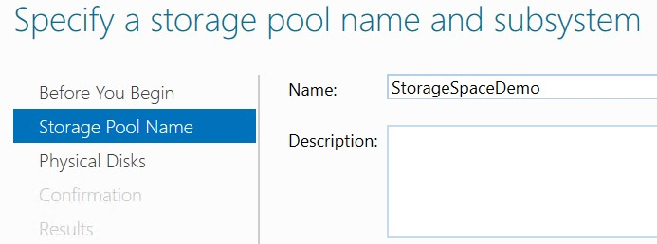

- Select both disks and click Next.
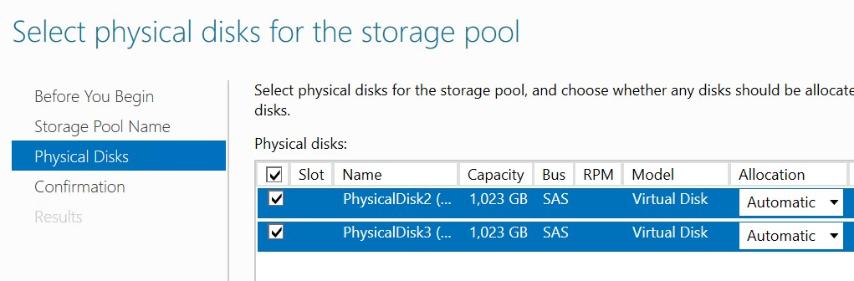

- Click Create on the confirmation step and then Close after the storage space is created.

- Right click on the new Storage Space, and click New Virtual Disk.
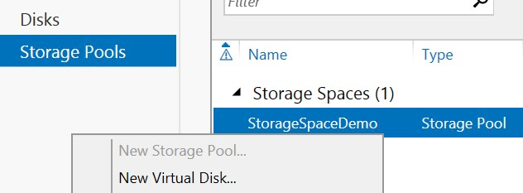

- Click Next on the Before You Begin dialog, and the select the Storage Pool created earlier.

- Name the disk AzureDisk and click Next.
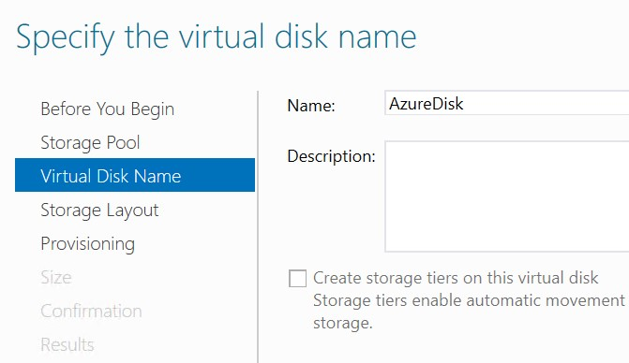

- For Storage Layout select Simple, and then click Next.
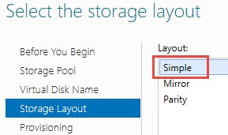

14.

Accept the default of fixed
.

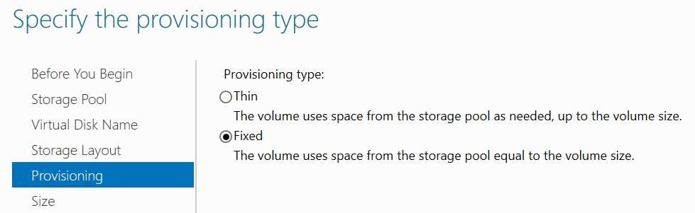

  - Change the Size to Maximum size.
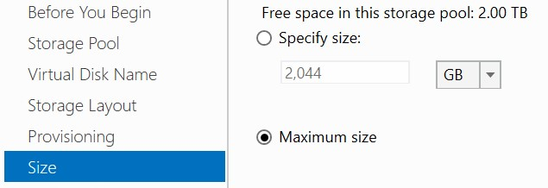

  - Click Create on the confirm dialog and Complete the New Volume Wizard by accepting the default settings for all dialogs. Note: if the default drive letter is E, change it to F.

  - At the end of the lab you should have a new 2 TB volume spread across two disks.
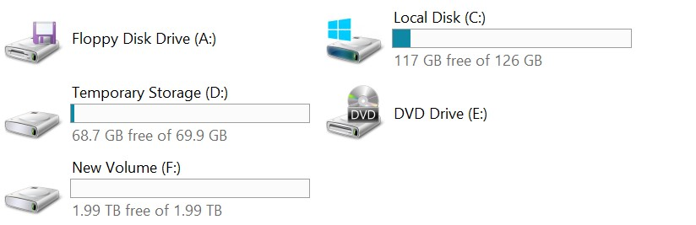

18.

Disconnect from Remote Desktop Session.

Exercise 3: Using the Azure Storage Explorer Utility to Copy Disks
- From LABVM download and install Microsoft’s Azure Storage Explorer from http://storageexplorer.com/.
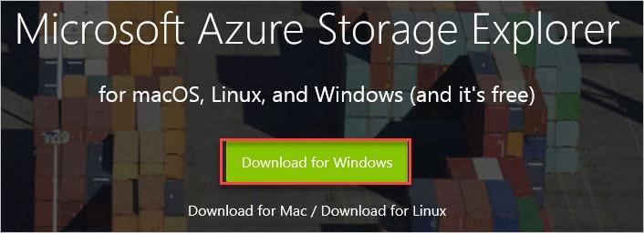
- After the application starts, click the User icon to configure access to your Azure subscription.
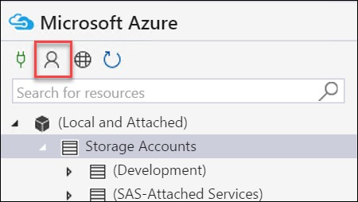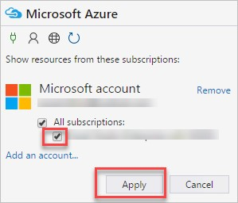
- Add your account by logging in with the credentials for your Azure Subscription.
If you have multiple subscriptions associated with your Microsoft account, you will be able to filter them out to the subscription you are using for the lab.

- Double click the storage account used by the virtual machines in earlier labs.
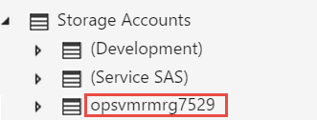

- Expand Blob Containers. You should see the containers for the boot diagnostics screenshots of your virtual machines, and the vhds container. This is the default location where the virtual hard disk (VHD) files for your virtual machines are stored.
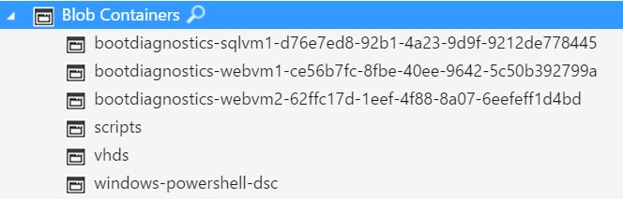

- Right click on the Blob Containers node and click Create Blob Container.
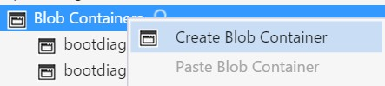
- Name the new container diskcopies.


- Double-click on the vhds container to see its contents and then sort by Blob Type until Page Blob is first, select all of the Page Blob items, right click and click Copy.
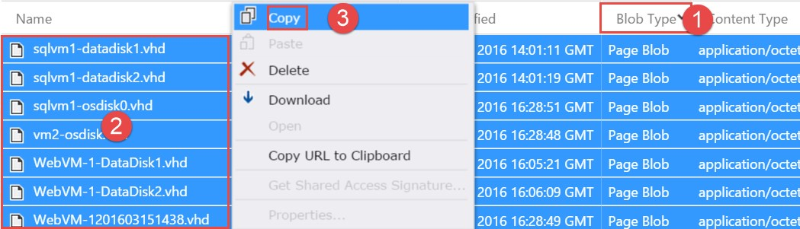

- Double-click the diskcopies container, after it opens click Paste from the toolbar.
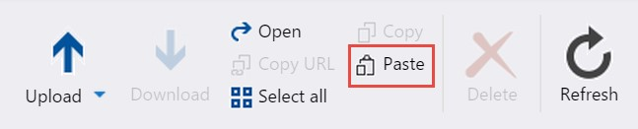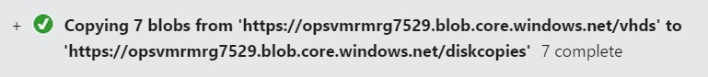

Tip: This tool can be used to copy files to different storage accounts even in remote regions.

Exercise 4: Using the Storage Explorer Utility to Upload a Disk
1. Within the Storage Explorer Utility, open the vhds container of the storage account for your virtual machine.
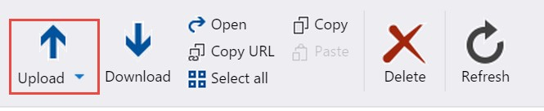

2.

Click the
Upload

button from the toolbar.

- Click the Upload Files menu item.
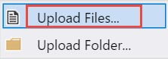
- In the Upload files dialog, browse to C:\OpsgilityTraining\DataDisk.vhd and click Upload.
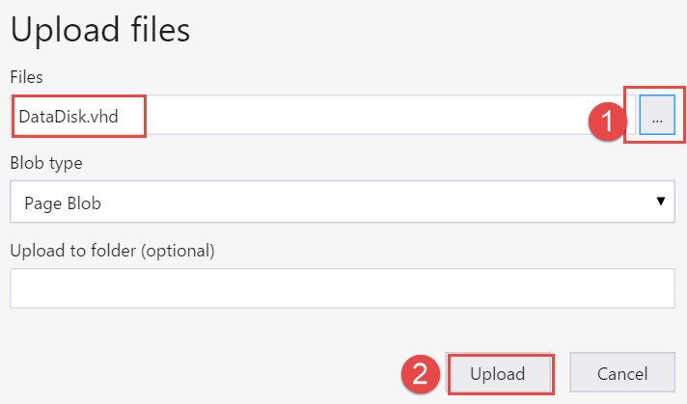

- Switch back to the Azure Management Portal and open the WebVM-2 virtual machine configuration by clicking Browse, Virtual Machines, and WebVM-2.

- Click Disks.


- Click Attach Existing.


- Browse to the storage account you uploaded the DataDisk.vhd file to, open the VHDs container, and select the DataDisk.vhd file, click the Select button at the bottom of the blade, and then click OK to attach it has a data disk.
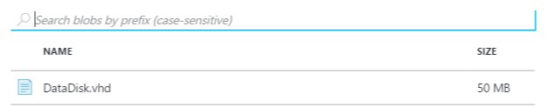

- Login to the WebVM-2 virtual machine by clicking the Connect button on the toolbar of the virtual machine.

- From within the virtual machine click the File Explorer icon.
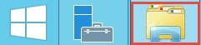
- Navigate to the F: drive (may be E:) and note the disk is attached with data loaded from the uploaded VHD.
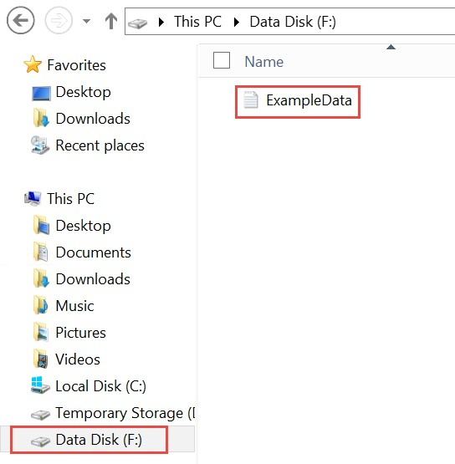

Exercise 5: Viewing Diagnostics Data

- The Cerebrata Azure Management Studio (AMS) application can be used to analyze diagnostics data stored in Azure Storage (among other things). From LABVM Download and install a trial version of the application here: http://www.cerebrata.com/.
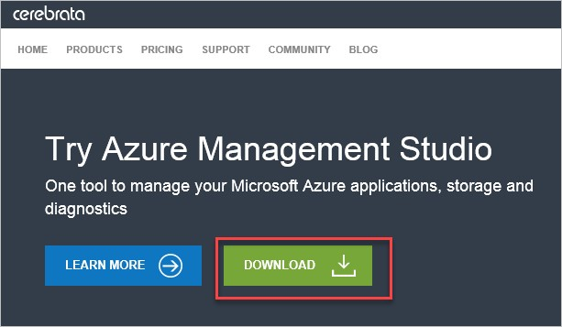
- The AMS application requires the storage account name and the storage account key. Copy the key by launching the Azure Management Portal, click Browse, Storage Accounts, and click the storage account with ‘diag’ in the name, such as ‘opsvmrmrgdiag655’ for example.

- On the Storage Account blade, note the storage account name, and click the Access keys tile.
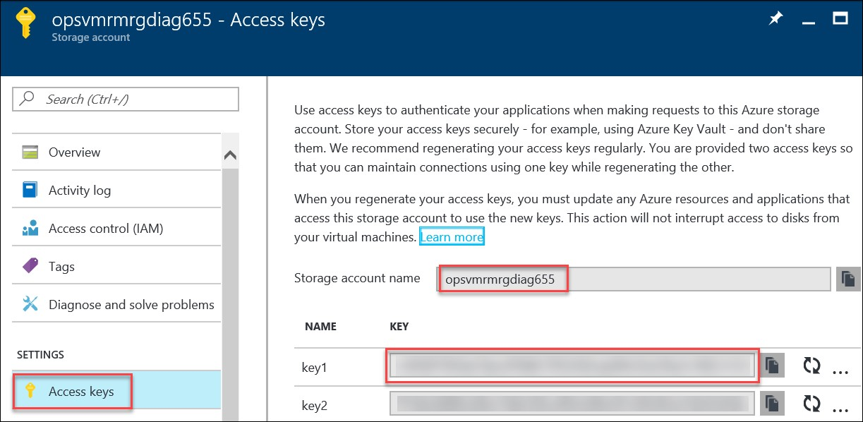

- Copy the value for KEY1.

- Within the AMS application, click Add Storage Account Connection.
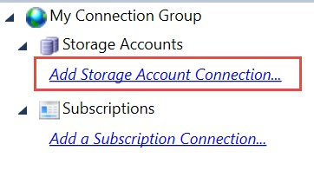

- Click Add a Windows Azure Storage account.
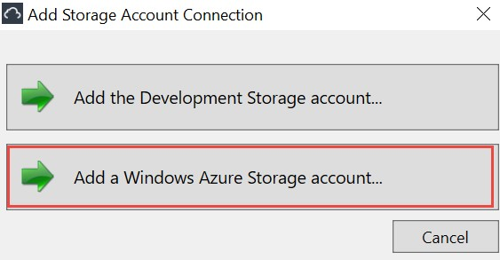

- Add the Storage Account name, and the Storage Account Key to the dialog and click OK.
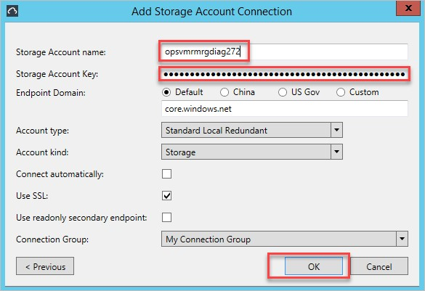

- Expand the storage account, expand tables and Blob Containers. This is the location of the raw data stored for Azure Diagnostics. The WADWindowsEventLogsTable can be queried to view the event logs from the VM. The WADMetrics* tables contain the captured performance counters in their raw form. The wad-iis-logfiles container (under Blob Containers) stores the IIS
log files, and if configured through the XML configuration additional log files could be captured and stored in blob storage as well.
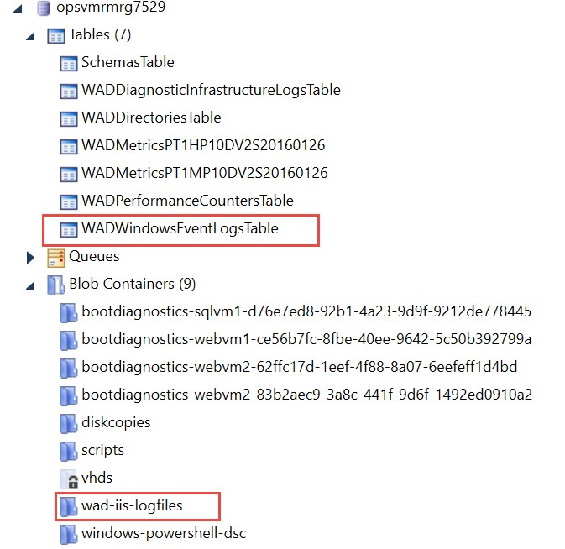

- After the next synchronization (within an hour) you will see a new container created named wad-iis-logfiles.
Note: If the log files are not synchronized yet, you can revisit this step later.

- If configured through XML you can capture Crash Dumps, and IIS Failed Request Logs. In this example you should be able to view the IIS Logs and Performance counters.
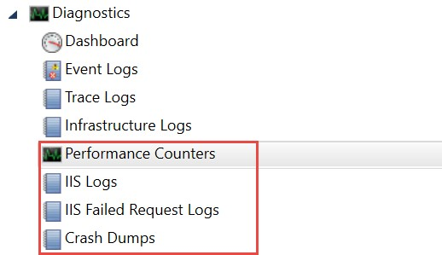

L
ab
Summary

In this lab, you learned how to attach additional storage from the Azure Management Portal and manage the underlying storage using Azure Storage Explorer.

